**NAME: Puspita Das**

**ID: 20301246**

**Sec: 12**

1. **a.**

hp@hp-HP-280-Pro-G6-Microtower-PC:~$ touch 20301246_1.txt 20301246_2.txt 20301246_3.txt 20301246_4.txt

hp@hp-HP-280-Pro-G6-Microtower-PC:~$ mkdir Puspita1 Puspita2

hp@hp-HP-280-Pro-G6-Microtower-PC:~$ mv 20301246_1.txt 20301246_2.txt 20301246_3.txt Puspita1

hp@hp-HP-280-Pro-G6-Microtower-PC:~$ cp Puspita1/20301246_1.txt Puspita1/20301246_2.txt Puspita2

hp@hp-HP-280-Pro-G6-Microtower-PC:~$ mkdir Puspita3

hp@hp-HP-280-Pro-G6-Microtower-PC:~$ cp -r Puspita1 Puspita3

hp@hp-HP-280-Pro-G6-Microtower-PC:~$ cd Puspita3

hp@hp-HP-280-Pro-G6-Microtower-PC:~/Puspita3$ ls -l

hp@hp-HP-280-Pro-G6-Microtower-PC:~/Puspita3$ chmod go=rx *

hp@hp-HP-280-Pro-G6-Microtower-PC:~/Puspita3$ cd ..

hp@hp-HP-280-Pro-G6-Microtower-PC:~$ ls -l

hp@hp-HP-280-Pro-G6-Microtower-PC:~$ mv Puspita3

hp@hp-HP-280-Pro-G6-Microtower-PC:~$ rm -rf Puspita1 Puspita2

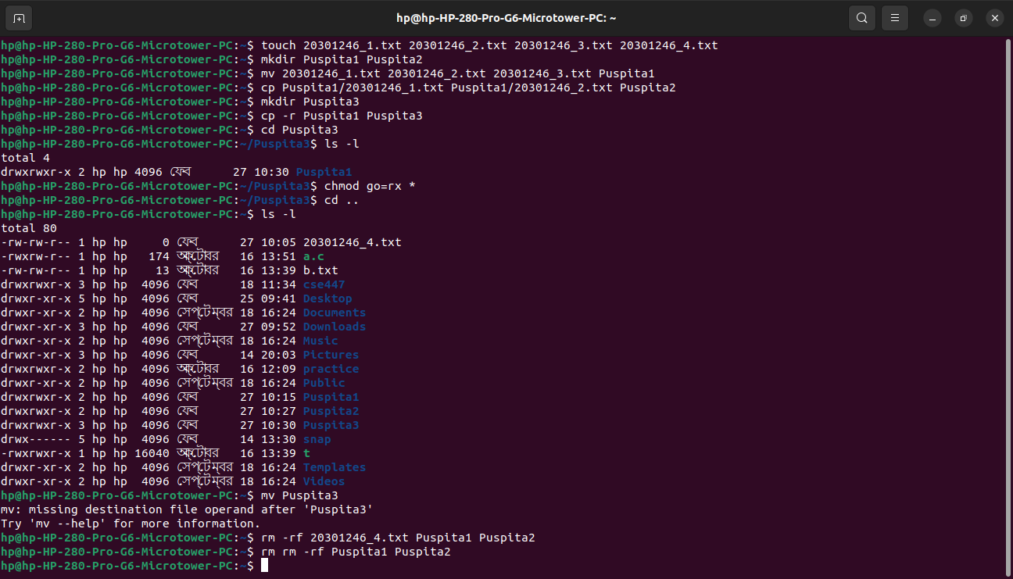

**b.**

ub71103-pc-13@ub71103pc13-HP-280-Pro-G8-Microtower-PC:~$ cat>course.txt

CSE470 Software Engineering Sec-3

CSE321 Operating system Sec-12

CSE341 Microprocessor Sec-06

PSY101 Introduction to Psychology Sec-07

ub71103-pc-13@ub71103pc13-HP-280-Pro-G8-Microtower-PC:~$ grep -c "CSE" course.txt

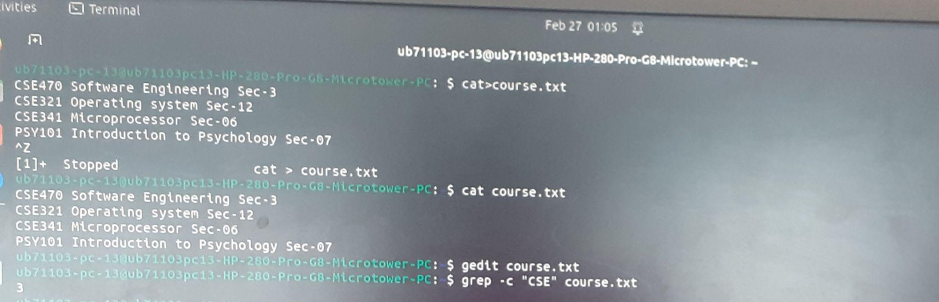

**c.**

ub71103-pc-13@ub71103pc13-HP-280-Pro-G8-Microtower-PC:~$ ls -a

. .cache Downloads .profile Templates

.. .config .gnupg Public Videos

.bash_history course.txt .local snap

.bash_logout Desktop Music .ssh

.bashrc Documents Pictures .sudo_as_admin_successful

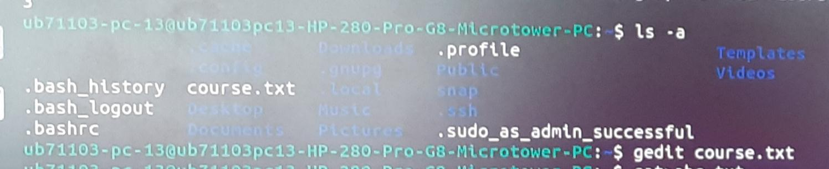

**d.**

ub71103-pc-13@ub71103pc13-HP-280-Pro-G8-Microtower-PC:~$ cat>abc.txt

heaven when i

held me again

how could you

basically you need to know

life is so beautiful if you want to see it beautifully

trust me

i know now all happened is not for your favor

but GOD is always with us

subway surface

temple run

project makeover

ludo star

candy crush

angry bird

cooking chef

pubg

crashland

repky 1988

sorry

reply 1988

ub71103-pc-13@ub71103pc13-HP-280-Pro-G8-Microtower-PC:~$ head -n 17 abc.txt|tail -n +5

life is so beautiful if you want to see it beautifully

trust me

i know now all happened is not for your favor

but GOD is always with us

subway surface

temple run

project makeover

ludo star

candy crush

angry bird

cooking chef

pubg

crashland

